How To Setup Your Recording Connection Student Site!
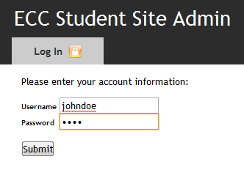
With our easy to use content management system, you can quickly establish your online presence by sharing information about yourself, images, videos, and audio, and blogging. This guide will walk you through the various features so that you can begin with ease!
In order to get started, you’ll need to log in the ECC Student Site Admin to access the various capabilities described in this guide. Your log in and password, as well as your unique Student Site Admin URL were e-mailed to you when your account was created.

Sections:
- Bio / Front Page
- Gallery
  - Images
  - Video
  - Audio
  - Editing and Deleting
- Blog
  - Adding a New Post
  - Posting to Twitter
  - Editing a Post
- References

- Bio / Front Page

The first step in establishing your ECC Student Site is setting up your front page content, which includes your name, picture, contact information, location, short biography, and more.
Step 1: Uploading a Profile Photo
Your profile photo will be displayed in our Student Directory, and on the main page of your Student Site. You should always pick a photo that best represents yourself! To upload a new profile photo, go to the Main Page / Bio section of the Student Site Admin. In the General Information portion, you will see your existing Profile Photo (or a No Image Available placeholder), with a link beneath it that says “Change Picture.” Click this to display the “Browse” or “Choose File” button (depending on your browser), and browse for the picture on your computer

Step 2: General Information
General information is where you will enter your Location, Age/Sex, Mentor, and other information that will be displayed on the front page of your Profile and in our Student Listings.

Step 3: Contact Information
Next, you’ll want to enter your Contact Information. Your E-Mail address will be used for the “Contact” form on your site, allowing visitors to get in touch with you without displaying your e-mail address. You can also enter your Facebook, Twitter, and LinkedIn information, and we’ll automatically place links to your profiles on your site!

Obtaining your Facebook ID
To set up your social media accounts for Twitter or LinkedIn, you just need to enter your username. For Facebook, however you will need to find your Facebook Account Number. To do this, log in to your Facebook account. On the top left, click on your name to go to your profile. Once there, look at the Location Bar of your browser, and you will see your numerical facebook ID at the end of the URL after “id=”.

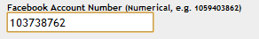
In this example, the Facebook ID is 103738762. This is what you would enter in the “Facebook ID” of the Student Site Admin. Don’t worry if your ID is a different number of digits, as this is normal.

Step 4: Bio
Tell your visitors a little about yourself with a 4-5 paragraph bio. You may want to cover your education and work history, interests and hobbies (if relevant), what you like best about your major, and more. Bear in mind your goal of selling yourself to your audience, so keep this information clean and relevant!

- Gallery
Image Gallery

The integrated image gallery allows you to instantly post images to your Student Site.
To begin, navigate to the Gallery using the top menu of the Student Site Admin, and click “Add Image” under the Image heading. This will display the “Add Image” form.
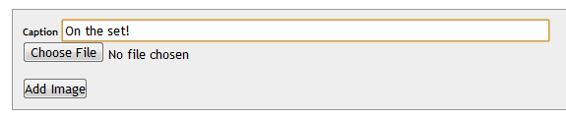

Enter a Caption, then click Choose File or Browse (depending on your Web Browser). Then, click Add Image and your file will begin uploading. There may be up to a 30 second delay once you click Add Image, so be sure to only click the Add Image button once.
Video Gallery
Your Student Site is integrated with YouTube’s video player, allowing you to easily add videos to your gallery, while giving you the added benefit of promoting yourself and your site on YouTube. To begin, simply create a YouTube account and begin uploading your videos.

To add a YouTube video to your Gallery, navigate to the Gallery using the top menu of the Student Site Admin, and click “Add Video” under the Video heading to display the “Add Video” Form.
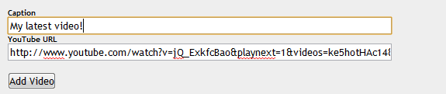
Enter a Caption, followed by the URL of your YouTube Video. Then, click “Add Video” and your YouTube video will be instantly added to your gallery.

Audio Gallery
Much like the Video Gallery, your Audio Gallery integrates with SoundCloud to make sharing even easier. Create a SoundCloud account and begin uploading your audio sets!
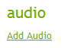
To add a SoundCloud Set to to your Gallery, navigate to the Gallery using the top menu of the Student Site Admin, and click “Add Audio” under the Audio heading to display the “Add Audio” Form.
Navigate to your set on Soundcloud and click the “Share” button on the top-left of the player to open the Share dialog. Click “More” on the top right, and select Wordpress. This will display a Wordpress tag similar to: [soundcloud url="http://api.soundcloud.com/playlists/418207"]. Paste this into the “Wordpress Share Code” field of the Student Site Admin to display the set on your profile.

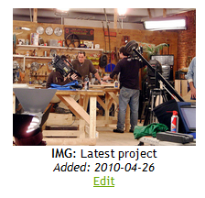
Editing and Deleting
To change a caption or delete an entry from your gallery, navigate to the Gallery section of the Student Site Admin, find your gallery element, and click the “Edit” link beneath the it. This will bring you to the Edit Form.
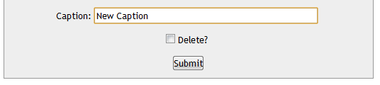
Simply enter your new caption and click Submit to instantly change the caption displayed in your gallery.
To delete an image, video, or audio entry from your gallery, check the “Delete” checkbox and click Submit.

- Blog
Your student site features a blog to share your experiences and tell your visitors a little more about yourself. Just click on Blog on the top navigation menu of the Student Site Admin to get to the Blog management section.


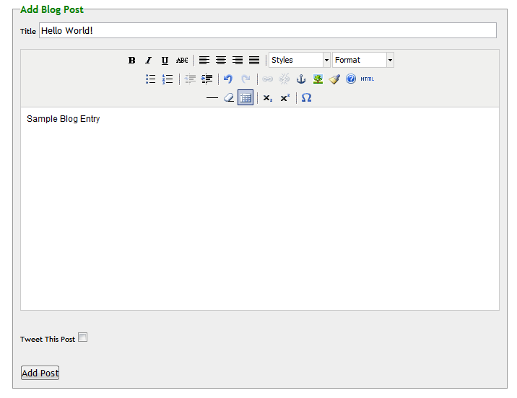
Adding a Post
To add a post, go to the Blog section of the Student Site Admin and click “Add Post.” This will bring you to the Add Blog Post form.

Simply enter the title and body of your blog post.
Posting to Twitter
Your blog also conveniently allows you to Tweet your posts to draw additional traffic to your Student Site. This requires a valid Twitter account. To post to Twitter, just complete your blog post in full, and then click on the “Tweet This Post” checkbox.
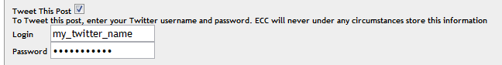

This will expose a section of the form where you may enter your Twitter account information. Once you click Add Post, your post will be added to your blog, and posted to Twitter. All Tweet posts contain the Title of your Blog Entry, and a direct URL to it.

Editing a Post
Your blog entires are listed in the Blog section of the Student Site Admin. To Edit a blog entry, click on the “Edit” link for the post you would like to edit.
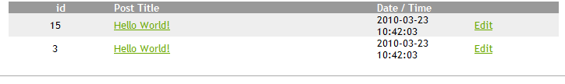
This will bring you to the Edit Blog Post form, where you can modify the title and content of your post.

IV References
References & Testimonials may be added to your Student Site from the References section of the Student Site Admin. To add a reference, click “Add Another.” You may enter the Name, Title, Company, and Comments for any testimonials or references you would like to add.
Your mentor has access to your Testimonials section as well, and may post their opinions from time to time!

