MIKING A VIOLIN/VIOLA (pg 167)
Frequency range is from 196 Hz to above 10 kHz. Microphone with good, flat frequency response should be used (300 Hz, 1 kHz and 1200 Hz). Mic should be placed within 45° of the front face. Distance should depend on particular style of music being recorded. Further = mellow, well-rounded tone; Closer = scratchy, nasal quality

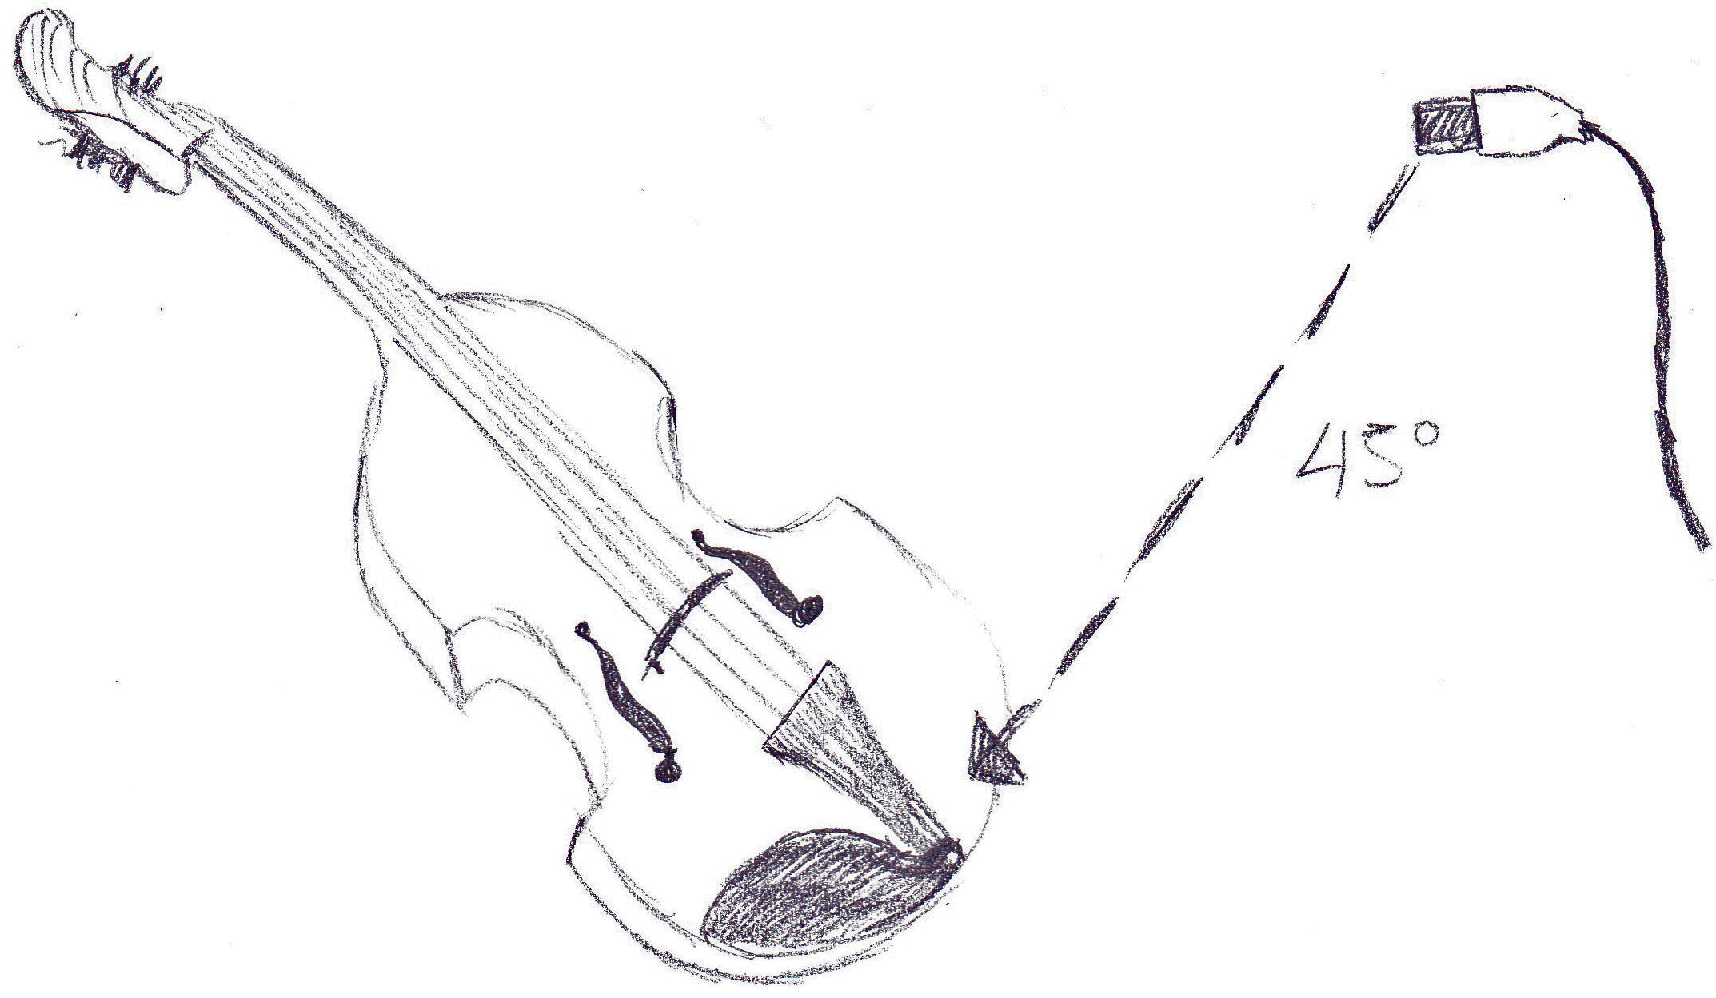

MIKING AN ACOUSTIC GUITAR (pg. 142-143)
Two techniques can be used: Spaced Stereo Miking or X/Y Stereo Miking.
Spaced can be placed infront to capture overall stereo image, and at a distance of a few feet to more than 30 feet apart. Phase inconsistency can be a drawback.
X/Y uses two identical microphones faced at 90° to 135° angles as close as possible without touching grills. No significant phase issues arise. Stereo imaging is often better than spaced. Cardioid polar pattern mics are recommended for this technique.

