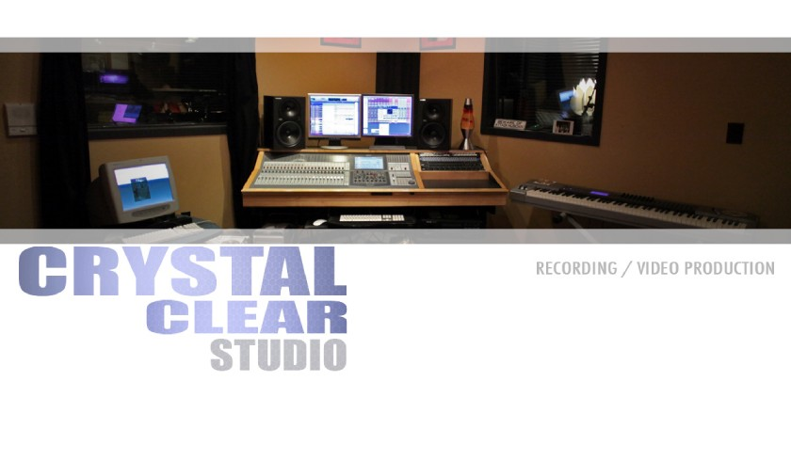
To Whom It May Concern:

I am pleased to recommend to you my apprentice, Ari Kabore. As my capacity as professor, producer, and owner of Crystal Clear Recording Studios, I have worked closely with Ari since August 2012.

I have had the pleasure of having Ari as my student . Ari has demonstrated great technical aptitude with, always maintaining the passionate desire to learn and succeed within the music industry. In addition to his mastery of the technology, Ari also brings a polished professionalism to the industry. He is a team player with great interpersonal skills, always eager to work with my team for the benefit of my Company.

Throughout his course work and apprenticeship, Ari became proficient in Pro Tools 10 and Reason 6 software suites, as well as, mastering my recording studio’s professional equipment, including the studios’ Sony DMX R100 Soundboard. In addition to the actual course load, Ari gained immeasurable real world experience in recording live bands, allocating the correct microphone for the specific instruments, and mixing down tracks. Most students do not get the opportunity of hands-on experience in the early phases of the course. Ari however, was eager and enthusiastic to take on the challenge right from the start, excelling quickly by demonstrating determination with pure motivation.

This is a great example of his discipline, focus and ability to compile and produce every aspect of a project. He shares an unbridled enthusiasm and passion for music, at the root of it all.

I would consider Ari to be an asset to any organization in the recording business. Once again, I would recommend Ari to you without reservation, as his drive and skills will truly be an asset in any company.

Best regards,

Joey Heier
Crystal Clear Recording School and Video Production
sachmo@crystalclearstudio.com
http://crystalclearstudio.com

