Michael G. McAfee
4993 Muir Avenue
San Diego, CA 92107
858.405.1060
Mikegmcafee@gmail.com

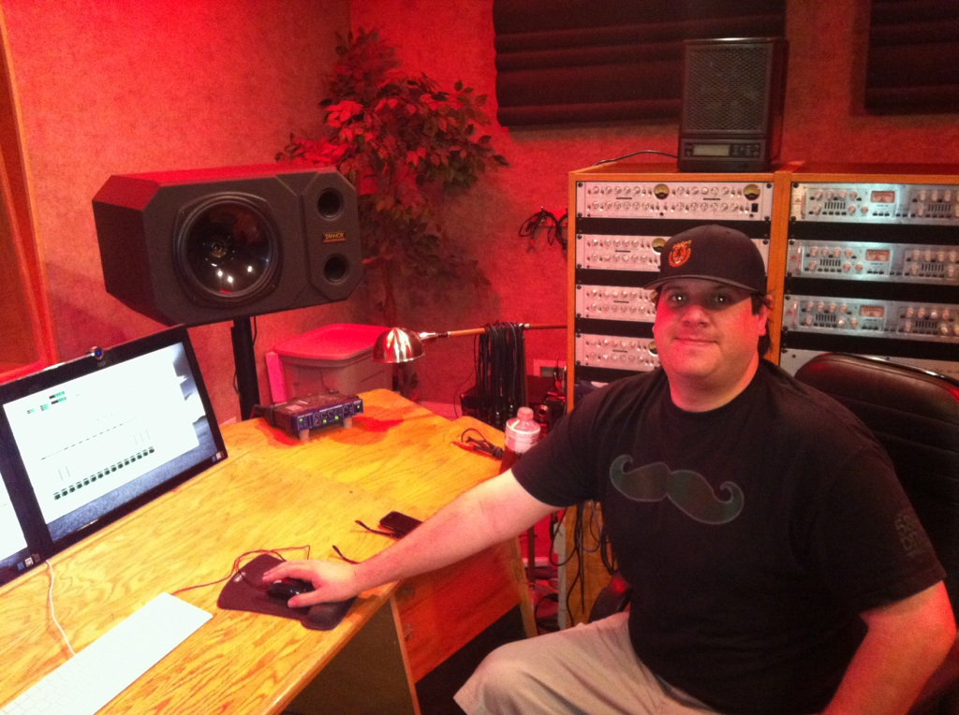

Experience:

- Sound Engineer, Gallagher's
2010 - current Ocean Beach, CA
Responsible for set up, operation and tear down of all audio equipment for use in live and recorded music on site. Insured that sound levels exceeded entertainer, venue and industry standards. Proficient with 24 channel mixing board, Pro Tools HD and LE, Logic Pro and Reason.

- Engineer/Producer Apprentice, Track Star Studios
January 2012- current La Mesa, CA.
Assist engineers and producers with a variety of duties including audio post production, recording, composing, mixing and mastering. “Assistant Producer” on the soundtrack for soon-to-be-released MTV reality show “Catfish.”

- Co-Host, A Sunny Place for Shady People podcast
July 2012- current Ocean Beach, CA
Co-Host a San Diego music scene podcast available on iTunes and Stitcher Radio. Develop working relationships with local bands, musicians and promoters to book and interview.

- Operations Manager, Whitefeather Enterprises
November 2007 - December 2011 Escondido, CA
Managed day-to-day operations, including sales and marketing, of family owned Native American art business. Primary clients include a number of large Southern California tribal governments.

- Recreation Director, Campland on the Bay
April 2002 - March 2006 San Diego, CA
Oversaw all recreation and entertainment activities for vacation camping resort which services over 500,000 guests annually. Negotiated and booked live entertainment for weekly concerts. Responsible for hiring, training and direct supervision of 4 full-time staff, as well as, up to 4 part-time seasonal employees.

Education:

- Recording Connection, Los Angeles, CA
Audio Engineering, September 2012
Graduated as a featured student, 4.0 GPA
Masters Certification for Avid Pro Tools HD and LE 10.

- The University of Arizona, Tucson, AZ
B.A. Journalism, 2002
Emphasis on Associated Press writing style. Served as the Sports and Opinions Editor for the school run newspaper, The Tombstone Epitaph. Minor in Ethnic Studies.

