[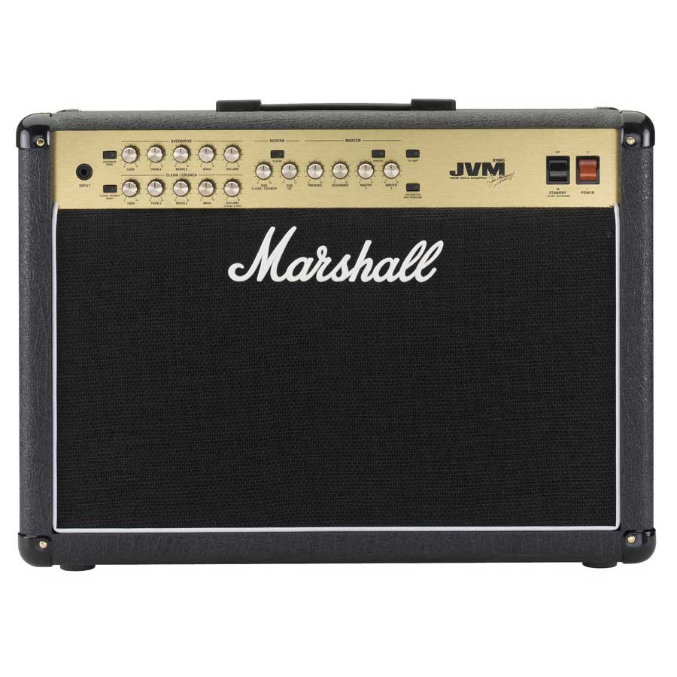](http://www.dv247.com/guitars/marshall-jvm210c-all-tube-guitar-amp-combo-100w-2x12--60746)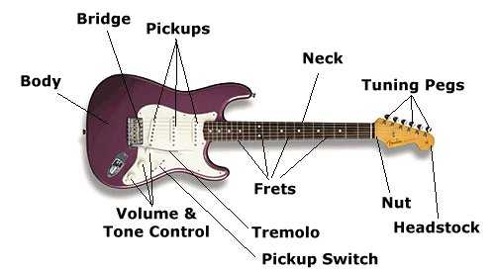

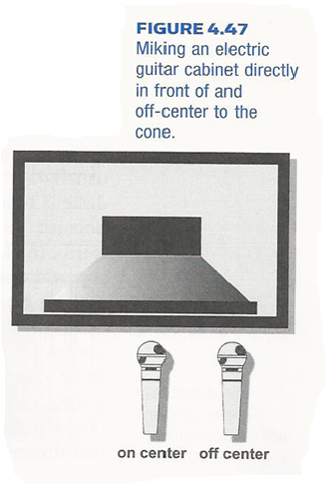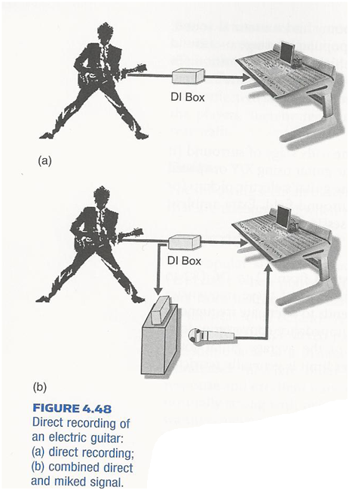

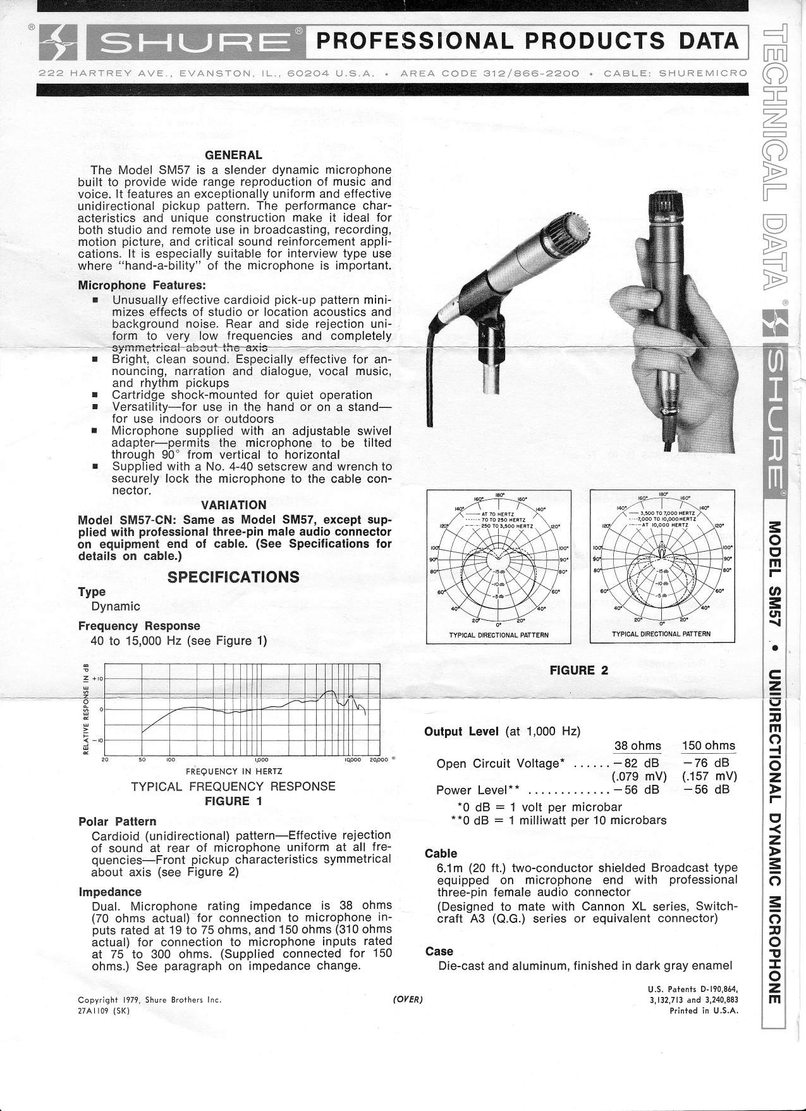

So how do you mic an electric guitar? Well, there are endless ways to mic an electric guitar and none of them are correct or wrong. If it sounds good when you record it do it. The two ways to mic an electric guitar that is talked about in Modern Recording Techniques (pages 153-154). The first is taking a Shure SM57 and micing the cabinet directly in front of and off- center to the cone as shown in figure 4.47 from Modern Recording Techniques. The second is recording direct through a DI Box or recording through a DI Box and micing the cabinet with a Shure SM57 as shown in figure 4.48 from Modern Recording Techniques.